File Creation Task

Task Description:

- Create a directory called ""my_folder"", navigate into it, and create a file named ""my_file.txt"" with some text. Then, create another file named ""another_file.txt"" with some text. Concatenate the content of ""another_file.txt"" to ""my_file.txt"" and display the updated content. Finally, list all files and directories in the current directory.
- Create 20 files with .txt extensions and rename the first 5 files to .yml extension and Print the latest created top 5 files among the total no of files".

Techstacks used :

- Gitbash

Steps:
Task 1
- Create the directory named my_folder
mkdir my_folder

- Navigate into the new directory:
cd my_folder

- Create the first file named my_file.txt with some text

echo "This is the content of my_file.txt." > my_file.txt

- Create the second file named another_file.txt and add some text:
another_file.txt


- Concatenate the content of another_file.txt to my_file (using >> for append):
cat another_file.txt >> my_file.txt

- Display the updated content of ̌my_file.txt
cat my_file.txt

- List all files and directories in the current directory my_folder

ls -l

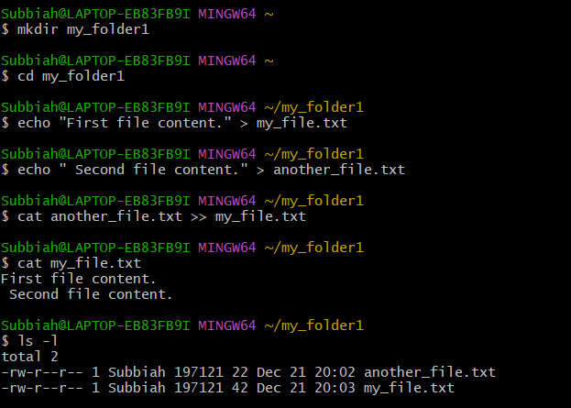

Task 2
Steps:
- Create 20 files with .txt extensions (e.g., file1.txt to file20.txt):
for i in {1..20};

- Rename the first 5 files to .yml extension (e.g., file1.yml to file5.yml):
for i in {1..5}; do mv "file$i.txt" "file$i.yml"; done
- Print the latest created top 5 files (This command lists files by modification time, most recent first, and takes the top 5):
ls -tc | head -n 5
